**INDEX**

|  |  |  |
| --- | --- | --- |
| **Sr. No** | **Title** | **Page no** |
| 1 | **CHAPTER 1 : INTRODUCTION** |  |
|  | 1.1 Company Profile |  |
|  | 1.2 Introduction |  |
|  | 1.3 Existing System and Need for System |  |
|  | 1.4 Limitations of existing system |  |
| 2 | **CHAPTER 2 : PROPOSED SYSTEM** |  |
|  | 2.1 Problem statement |  |
|  | 2.2 product position statement |  |
|  | 2.3 product overview |  |
|  | 2.4 summary of capabilities |  |
|  | 2.5 assumptions and dependencies |  |
|  | 2.6 objective of proposed system |  |
|  | 2.7 Functional requirements |  |
|  | 2.8 Nonfunctional requirements |  |
|  | 2.9 Stakeholder summary |  |
|  | 2.10 Users summary |  |
|  | 2.11 Scope of the system |  |
|  | 2.12 Operating environment |  |
|  | 2.13 Operating environment |  |
| 3 | **CHAPTER3 : REQUIREMENT DETERMINATION AND ANALYSIS** |  |
|  | 3.1 Fact finding methods |  |
|  | 3.2 feasibility study |  |
| 4 | **CHAPTER 4 : SYSTEM ANALYSIS & DESIGN** |  |
|  | 4.1 Use case diagram |  |
|  | 4.2 Sequence diagram |  |
|  | 4.3 Activity diagram |  |
|  | 4.4Class diagram |  |
|  | 4.5 Object diagram |  |
|  | 4.6 Module hierarchy diagram |  |

**CHAPTER 1: INTRODUCTION**

**1.1 Company Profile**

**Premium Learning Systems Private Limited** was established in January 2015 with a primary motto to support teams and individuals with world class trainings on premium skills like Cloud computing, Data Science, Social Media Marketing and DevOps. We primarily focus on customized software and technology trainings programs for our clients across the world.

**Premium Learning Systems Private Limited** is based in Pune and its serving their clients across the world through their training services. Our client base includes Adobe, Accenture, Capgemini, Vodafone, Barclays,SLKirloskar Group, Tavant Technologies to name a few.

* **How We Work**

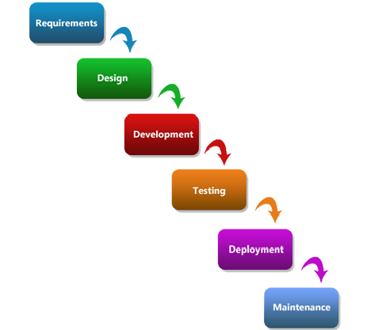

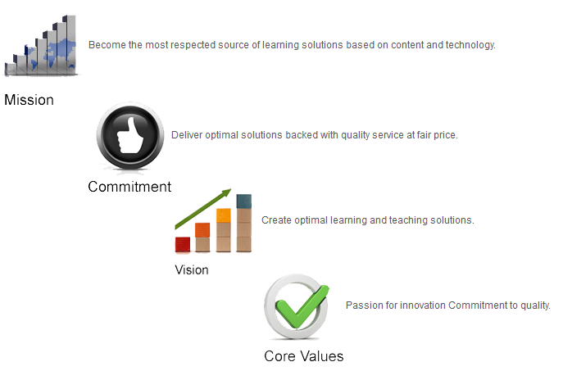

**1.2 Introduction**

**CRM (Sales, Service and Marketing Cloud )**

This customized CRM is implemented for Sales, service and marketing process on cloud using salesforce cloud. Marketing cloud comprises of adding leads and contacts to Campaigns and following up on them even after conversion of leads. Sales cloud comprises of Lead creation manually, through web and email. Email notifications are sent to Leads and owners and sales processes are followed according to the organization. Using time based emails leads are nurtured and converted to Account, contact and deals (opportunities) using custom convert functionality.Duplicate Leads are deleted by a scheduled job on the basis of business cases periodically.Once the deal is closed customer can create cases manually or through emails and it’s assigned to relevant owners according to business logic.Same scheduled duplicate deletion is implemented on cases. In this project we are provides the Cloud application for particular Client. The main purpose of this project is to provide the user friendly Cloud application. That means the user(client) can easily access the all Services those are provided in this application. The different Users access different features and different page layout also according to user role. The user is also responsible this related task. In this projects we are use the Visual Force, CSS, JavaScript for creating the web pages and implement the business logic through Apex (On demand Object Oriented Programming language).and stores the data using cloud inbuilt database like oracle.

**Cloud Computing**

Cloud-based (or cloud computing) means that the applications are delivered over the Internet and run in any Web browser so that you can access them from any smart device.No Hardware, No Software.Cloud Computing applications are less expensive than desktop software because you only pay to use the software instead of having to buy, install, configure, and maintain it.It’s effectively infinite in size, so you don’t need to worry about it running out of capacity.

**CRM(customer relationship management)**

CRM stands for “customer relationship management” and its software that stores customer contact information like names, addresses, and phone numbers, as well as keeps track of customer activity like website visits, phone calls, email, and more.

CRM helps you ditch clunky processes and manual effort so you can get on with business.One place to store all customer information means your conversations are always personal, relevant, and up to date. Customer Relationship Management (CRM) is a strategy for managing all your company's relationships and interactions with your customers and potential customers. It helps you improve your profitability. If your business is going to last, you know that you need a strategy for the future. You’ll already have targets relating to sales, business objectives and profitability. But getting up-to-date, reliable information on your progress towards your goals can be tricky. How do you translate the many streams of data coming in from sales teams, customer service staff, marketers and social media monitoring into useful business information? Using a CRM system can give you a clear overview of your customers. You can see everything in one place a simple, customisable dashboard that can tell you a customer's previous history with you, the status of their orders, any outstanding customer service issues, and more.Actively tracks and manages customer information.

* Connects your entire team from any device.
* Intelligently captures customer emails.
* Simplifies repetitive tasks so you can concentrate on leads.
* Delivers instant insights and recommendations.
* Extends and customizes as your business grows.

# Force.com

Force.com is a Platform as a Service (PaaS) product designed to simplify the development and deployment of cloud-based applications and websites. Developers can create apps and websites through the cloud IDE (Integrated development environment) and deploy them quickly to Force.com multi-tenant servers.

**1.3 Existing System and Need for System**

* **Existing System**

There are not any existing systems for client side. So all the work are handling manually and have to be noted down in some register and also taking care of that documentation.

To give any information to Student it does the personal call or sends personal emails or text messages without automatic process. They are arranged meeting by call and if any update occurred then again cell the Student and update meeting schedule, its wasting time and as well as money also the disturb the valuable Employee as well as Students.

* **Need for System**

We are Develop the Custom CRM(Sales, Services and Marketing Cloud) for Premium Learning System.To overcome over problems they are thinking to create such a system for the client as well as company use. In which we can silently telling the Student about their status and meeting schedule by mailing and sms.

This customized CRM is implemented for Sales, service and marketing process on cloud using Salesforce cloud. Marketing cloud comprises of adding leads and contacts to Campaigns and following up on them even after conversion of leads. Sales cloud comprises of Lead creation manually, through web and email. Email notifications are sent to Leads and owners and sales processes are followed according to the organization. Using time based emails leads are nurtured and converted to Account, contact and deals (opportunities) using custom convert functionality. Duplicate Leads are deleted by a scheduled job on the basis of business cases periodically. Once the deal is closed customer can create cases manually or through emails and its assigned to relevant owners according to a business logic. Same scheduled duplicate deletion is implemented on cases.By this system company having the lots of advantages by having a bulk year records and all the data together.

**1.4 Limitations of existing system**

Due to manual system has following limitations:

1. The existing system serves a major drawback to the realization of efficiency and customer satisfaction. The main limitation of the existing system is you cannot insert data in multiple ways.

2. The data storage will be also limited.

3. We cannot generate any automatic actions on your data just like sending automatic email when the new record is created duplicate records is deleted.

**CHAPTER 2 : PROPOSED SYSTEM**

**2.1 Problem statement/s**

CRM System is designed to overcome those problems using manual system such as the possibility the paper work is high. Previous Premium Learning System use conventional system which is on paper-based and MS-Excel Sheet, for Storing Student and Employee Information. Using conventional system, the Assistant must note down the information at paper and maintain the records for future use. The probability to make mistake was high because sometimes the missing some pages and delete some excel sheet files. Therefore CRM System is developed to enhance the efficiency, accuracy and security of handling Customers data. Besides that, conventional system cannot see the sales history therefore CRM System is designed to view the sales history of the User.

**2.2 Product position statement**

A CRM system can serve as a vital nerve center to manage the many connections that happen in a growing business. How do you translate the many streams of data coming in from sales, customer, service, marketing, and social media monitoring into actionable business information?  
  
A CRM gives everyone across the business, including sales, customer service, marketing, and business development, a better way to manage the customer relationships and interactions that drive success. With visibility and easy access to customer data, such as contact information, sales opportunities, service issues, and marketing campaigns, a CRM system can give you a clear overview of your customers. With an easy-to-use, customizable dashboard, you can see a 360-degree view of the customer, all in one place.

**2.3 Product overview**

This customised CRM is implemented for Sales, service and marketing process on cloud using Salesforce cloud. Marketing cloud comprises of adding leads and contacts to Campaigns and following up on them even after conversion of leads. Sales cloud comprises of Lead creation manually, through web and email. Email notifications are sent to Leads and owners and sales processes are followed according to the organization. Using time based emails leads are nurtured and converted to Account, contact and deals (opportunities) using custom convert functionality. Duplicate Leads are deleted by a scheduled job on the basis of business cases periodically. Once the deal is closed customer can create cases manually or through emails and its assigned to relevant owners according to a business logic.Same scheduled duplicate deletion is implemented on cases

**2.4 Summary of Capabilities:**

Proposed System is capable of managing multiple roles having different view of abstraction. User has to create the base of the functionality. Following are the summary of capabilities.

* 1. **Campaign Management- A campaign is an outbound marketing project that you want to plan, manage, and track within Salesforce. It can be a direct mail program, seminar, print advertisement, email, or other type of marketing initiative. You can organize campaigns into hierarchies for easy analysis of related marketing tactics.**
  2. **Case Management-**Represents a case, which is a customer issue or problem. Use the case objects to manage cases for your organization
  3. **Reports-** A report is a list of records that meet the criteria you define. It’s displayed in Salesforce in rows and columns

**2.5 Assumptions and dependencies**

The product does require back-end database server which are provide by the Salesforce.com for storing the all Customers data into table format for different types of user of the system.

1. The user is well familiar with internet connection and Computer System.

2. User must be trained for basic computer functionalities.

3. User must have the basic knowledge of English.

4. The System has Internet Connection for access all functionalities.

**2.6 Objectives of proposed system**

1. The Objective of this System is to Store And Manage all customers data and to Track the Customers’ activities.
2. To develop a system that will surely satisfied the Client Requirements.
3. To design a system able to accommodate huge amount of records at a time.
4. To evaluate its performance and acceptability in terms of security, user-friendly, accuracy and reliability.
5. The CRM system shall provide the page permission control. The user only can access to the pages which they are permitted. The permission control is based on user group management.
6. To automatically make actions on the data.The system will also automatically send emails to owner and customers for creating each and every record. And also delete the duplicate entries according to time based schedule.

**2.7 Functional requirements**

This section provides requirement overview of the system. Various functional modules that can be implemented by the system will be -

1. **Registration -**

If user wants to enter CRM system first registered your account, unregistered user can’t go to the CRM System.

1. **Login -**

User login to the system by entering valid user id and password.

1. **Marketing Cloud CRM**

* **Campaign Management-**

**A campaign is an outbound marketing project that you want to plan, manage, and track within Salesforce. It can be a direct mail program, seminar, print advertisement, email, or other type of marketing initiative. You can organize campaigns into hierarchies for easy analysis of related marketing tactics.**

**There are various way to Campaign-Conference, Email, Telemarketing, Public Relation, Partners, Advertisement, other.**

1. **Service Cloud CRM**

* **Case Management-**

Represents a case, which is a customer issue or problem.Use the case objects to manage cases for your organization.

-Customer can create Case by using Web, Email, Phone/Manually.

-Admin can assign Case to department, Verify Progress, and Check Status (Case Resolved/Not).

-Department can Identify Problems, Find Solution, Work on Case, and Closed Case

* **Email to Case generation using email services-**

Automatically create a case when an email is sent to one of your company's email addresses, such as support@company.com. This Email-to-Case functionality auto-populates case fields from the content of each email.

* **Scheduled deletion of duplicate Cases-**

Schedule means, we can schedule on duplicate Cases for every hour/day/week/month/year. Automatically delete the duplicate Cases by Scheduled deletion

1. **Reports**

A report is a list of records that meet the criteria you define. It’s displayed in Salesforce in rows and columns

1. **Dashboard**

Graphical representation of reports. Dashboards provide more insights than reports as they combine the data from many reports and show a summarized result. Looking at many reports at a time gives the flexibility of combining the results from them quickly. Also summaries in dashboards help us decide on action plans quicker. The dashboards can contain charts, graphs

1. **Lead**

Business entities that may be interested in the product

1. **Contacts**

Entities that are associated with organizations mentioned in an Account

**2.8 Nonfunctional requirements**

**Performance Requirements:**

The performance will be fully based on the Internet connection. The user may not worry their local system. The local system will be only used as a terminal.

**Safety Requirements:**

There are the possibilities of data loss due to the interruption of connection in Internet. So the user must ensure about his uninterrupted Internet connection.

**Security Requirements:**

All the security issue will be provided by the service provider itself (SALEFORCE.COM).No users are allowed to enter and view the details without proper authentication (password Protection).

**2.9. STAKEHOLDER SUMMARY**

**1. Login Module**

* User name
* Password

**2. Registration Module**

* First Name
* Last Name
* Email ID
* Role
* Company
* Country
* Postal Code
* Username

**3. Admin Module**

* Login an Account
* All Type of Access like to create new user and user profile
* To give the permission of users for accessing functionality
* Add, Edit, Delete, and View all data.

**4. User Module**

* Verify the account via email and Login an Account
* Manage the Campaign, Case, Account, Contact, and Opportunity ...Etc.
* Manage the Reports and Department data
* Manage all Automated actions such as send emails and avoid duplicate entries
* **Scheduled deletion of duplicate Case, Account, Contact and Opportunity**

**5. Manager Module**

* Verify the account via email and Login an account.
* To view the Reports and Dashboard

**2.10 Users summary**

The users expect the system to have the following capabilities:

A system to be able to:-

* Validating records i.e. checking for an already stores the records in same name and emails,checking the inputs is valid or not according to data type from the system.
* Allowing the user to add,remove or edit different records in each module like Sales, Services and Marketing Modules.
* Provide a suitable graphical user interface of only what is necessary for a particular operation without related confusions.
* Provide a separate PageLayout and separate functionalities according to user roles and responsibility.

**2.11 Scope of the system**

This System is totally web based and creating on cloud-based platform such as Force.com platform.

This software that stores customer contact information like names, addresses, and phone numbers, as well as keeps track of customer activity like website visits, phone calls, email, and more.

It is very helpful to any type of business to grow the business rapidly. The business like small scale business or large scale business. It used in any types of business.

Using this cloud-based Web application you can store the customer’s data on one place and you want to access it anytime and anywhere through Internet. This data is totally secure because you don’t know where is the data is stored.

* 1. **Module specifications**

1. **Registration -**

If user wants to enter CRM system first registered your account, unregistered user can’t go to the CRM System.

1. **Login -**

User login to the system by entering valid user id and password.

1. **Service Cloud CRM**

* **Case Management-**

Represents a case, which is a customer issue or problem.

Usage- Use the case objects to manage cases for your organization.

* **Email to Case generation using email services-**

Automatically create a case when an email is sent to one of your company's email addresses, such as support@company.com. This Email-to-Case functionality auto-populates case fields from the content of each email.

* **Scheduled deletion of duplicate Cases-**

Schedule means, we can schedule on duplicate Cases for every hour/day/week/month/year. Automatically delete the duplicate Cases by Scheduled deletion

1. **Marketing Cloud CRM**

* **Campaign Management-**

**A campaign is an outbound marketing project that you want to plan, manage, and track within Salesforce. It can be a direct mail program, seminar, print advertisement, email, or other type of marketing initiative. You can organize campaigns into hierarchies for easy analysis of related marketing tactics.**

1. **Reports**

A report is a list of records that meet the criteria you define. It’s displayed in Salesforce in rows and columns

1. **Dashboard**

Graphical representation of reports. Dashboards provide more insights than reports as they combine the data from many reports and show a summarized result. Looking at many reports at a time gives the flexibility of combining the results from them quickly. Also summaries in dashboards help us decide on action plans quicker. The dashboards can contain charts, graphs

* **Technology Description**

**About Developer Force:**

Developer force is a community of developers who customize and build applications that run in the cloud and are built with the Force.com platform. Developer force members have access to a full range of resources, including sample code, toolkit, and online developer community, and the test environment Necessary for building apps.The developer Force website includes an online version of this book and has information about the dream force event that we hold every year for Force.com platform developers.if we need more info. Have a question to ask, are seeking a toolkit or sample, or just want to dig. A little deeper into force.com platform development. Developer force is where it all comes together.

**The Basics of an App:**

If you haven’t used Salesforce.com before, you’ll find it worthwhile to log in and spend a bit of time clicking around.Most Salesforce.com editions (including Developer Edition) have a basic Salesforce.com SFA app, so we’ll start by looking at that.The interface for these tasks has a lot in common with the interface of whatever app you’re planning to build.

**Tabs:**

As you can see when you start clicking around, there are a few key elements that form the foundation of the Sales Automation app and of most applications created with the platform. First, across the top of the app is a set of tabs that segment the app into different parts.Each tab corresponds to a type of object, such as an account or contact, and within a tab you can perform actions on particular records of that tab’s type.For example, when you click on the Account tab, you can create a new record for the “TCS” account. You can also edit existing accounts, or use a list view to filter lists of accounts by creation criteria. Most app development work revolves around creating tabs and defining the data and behaviors that support them.

**Forms:**

A second key element in the form that is displayed as part of a tab.As in any business app, forms are the primary means of entering and viewing information in the system.Forms allow you to view and edit the data associated with a particular record on a tab, like the contact “Gaurav” on the Contacts tab.When developing a new app you can define what information appears in each form, and show it is organized.For example, the form for a contact record includes fields such a Last Name, Phone, Mailing City, Title, Birth date, Reports to and Account.In a Force.com platform app, the form used to enter information is referred to as an edit page and the read-only view of that information is referred to as a detail page.

**Links:**

Finally, because Force.com platform apps are delivered via a Web browser, they use links to provide navigation to related data.For example, on an account detail page, there are links to related records, such as the contacts that belong to account and the sales user who manages the account.

**2.13 Operating environment**

**SYSTEM SPECIFICATION**

* **Hardware Requirements:**

**Processor**: 32 bit Processor

**Ram**: 512 Mb

**Hard Disk**: 40 GB

**Internet**: 512 kbps high speed Internet connection

* **Software Requirements:**

**OS**: All OS supporting Internet browsing.

**Platform**: Force.com Environment.

**Languages**: Visual Force, Apex

**CHAPTER 3 : REQUIREMENT DETERMINATION AND ANALYSIS**

**3.1 Fact finding methods**

**Definition**:

**“The specific methods, techniques analyst used for collecting data about requirements are called as fact finding/gathering techniques.”**

Fact finding is the formal process of collect information about system and requirements. It is also called information gathering or data collection. It has to be gathered in an organized way so that no system details are left out, right problems are identified, repetitive work is avoided and wrong or incomplete details are not collected. Information gathering is very important while developing any application.

To understand the drawbacks in the existing system study was conducted by using following fact finding techniques.

Fact finding techniques are:

**1. Interview**

* **Structured Interview**
* **Unstructured Interview**

**2. Questionnaires**

* **Open ended questionnaire**
* **Close ended questionnaire**

**3. Observation**

* **Record Review**

**3.1.1. Interview:**

* **Definition:**

**“Interview technique is used to collect information from individuals or from groups.”**

The interview is best method for producing qualitative information, opinions, policies, suggestions, subjective description of activities and problems etc. Interview helpful for gathering information from individuals who do not communicate effectively in writing or who may not have time complete questioning.

We have taken interview of Manager Mrs. [Sudhanshu Jain](https://www.linkedin.com/in/sudhanshu-jain-%E2%98%81-56ab7a12/) of the Premium learning institute.

* **Interview can be of two types:**

**1. Structured Interview:**

Structured interviews are used standardized question in either open response or close response format. It requires deep study and preparation.

**2. Unstructured Interview:**

Unstructured interviews allows respondent to answer in their own words. Whereas a structure interview uses the set of prescribe answers. In this type of interview question are connected with last question so it does not required deep study and preparation.

**3.1.2. Questionnaires:**

* **Definition**:

**“A questionnaire is a research instrument consisting of a series of question for the purpose of gathering information from respondent.”**

Questionnaire may be used as a supplement to interviews. Questionnaires are useful for:

1. Gathering numerical data.

2. Getting relatively simple opinion from a large number of people.

3. Obtaining collective opinion.

4. Standardized question format can produce more reliable data than other fact finding techniques.

**There are two types of questionnaires:**

1. **Open ended questionnaire:**

Use open ended questionnaire to learn about feeling, opinion and general experience or to explore a process or problem.

1. **Close ended questionnaire :**

Close ended questionnaire controls the frame of reference by presenting respondent with specific responses from which to select. This format is appropriate for collecting factual information.

**3.1.3. Observation:**

* **Definition:**

**“Observation methods is most useful when the analyst need to be actually observe how documents are handle, how process are carried out and whether specified steps are actually followed or not.”**

Observation provides close view of the working of the real system. System analyst observes people, objects, documents and occurrences of events. Observation allows analyst to get information, which they cannot obtained any other fact finding technique.

1. **Record Review :**

In record reviews system analyst examines information that has been recorded about the system and about the users. The record review can take place at the beginning of the system study or in the later in the study for comparing actual operations with what the records indicate. Many records and reports can provide valuable information about organization and operation. Records may include written policy manuals, rules and regulations, standard operating procedures used in the organization and form and documents. We are maintain the records of customer detail, supplier detail, purchase details, sale details, item details, stock details and service details muster.

**3.2 Feasibility study**

A feasibility study is an evaluation of a proposal designed to determine the difficulty in carrying out a designed task. Generally, a feasibility study proceeds. Technical development and project implementation. In other words, a feasibility study is an evaluation or analysis of the potential impact of a proposed project.

**Economic feasibility:**

Economic analysis is the most frequently used method for evaluating the effectiveness of a new system. More commonly known as cost/benefit analysis, the procedure is to determine the benefits and savings that are expected from user system and compare them with costs. If benefits outweigh costs, then the decision is made to design and implement the system. An entrepreneur must accurately weigh the cost versus benefits before taking an action.

**Cost Based Study:**

It is important to identify cost and benefit factors, which can be categorized as follows: 1. Development costs and 2.Operating costs. This web application needs lessamount of cost in both development and operating state.

**Time Based Study:**

This is an analysis of the time required to achieve a return on investments. This Web application takes less time to execute and to use.

**Operational feasibility:**

is a measure of how well a proposed system solves the problems, and takes advantage of the opportunities identified during scope definition and how it satisfies the requirements identified in the requirements analysis phase of system development.The proposed system solves all the problems in the existing system in the basis of time, cost, risk, Etc.

**Technology and system feasibility:**

The assessment is based on an outline design of system requirements in terms of Input, Processes, Output, Fields, Program, and Procedures. This can be quantified in terms of volumes of data, trends, frequency of updating. Etc. in order to estimate whether the new systems will perform adequately or not.Technological feasibility is carried out to determine whether the company has the capability, in terms of software, hardware, personnel and expertise, to handle the completion of the project.The usage of this web application over cloud environment simply needs a uninterrupted Internet connection of 512kbps of speed.

**CHAPTER 4: SYSTEM ANALYSIS & DESIGN**

**4.1 Use Case Diagrams**

* **CASE**

**4.1.1-Use Case Diagrams For Create Case**

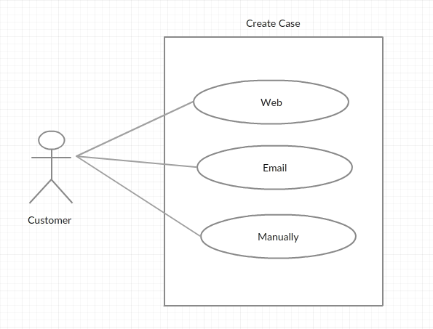

**4.1.2- Use Case Diagrams for Assign case**

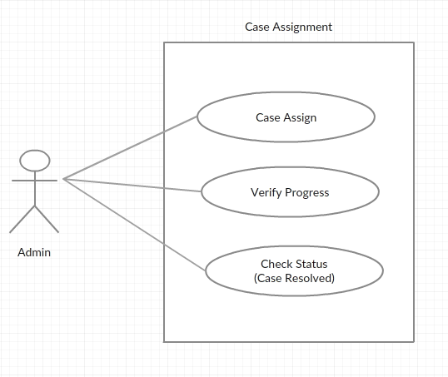

**4.1.3- Use Case Diagrams for Work on Case**

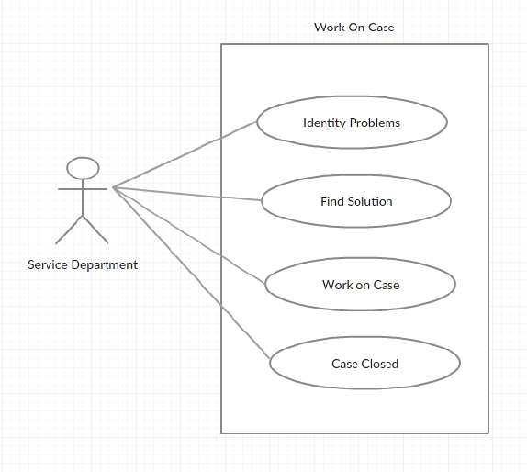

* **Campaign**

**4.1 .4- Use Case Diagrams for Campaign**

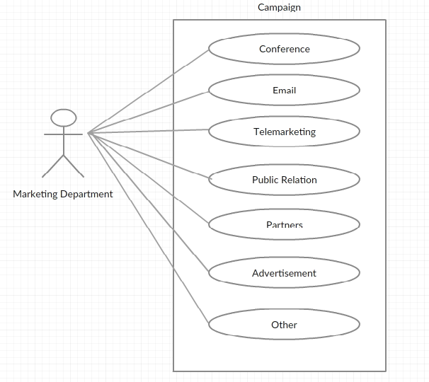

**4.2Sequence Diagram**

**4.2**.**1-Sequence Diagram for Login**

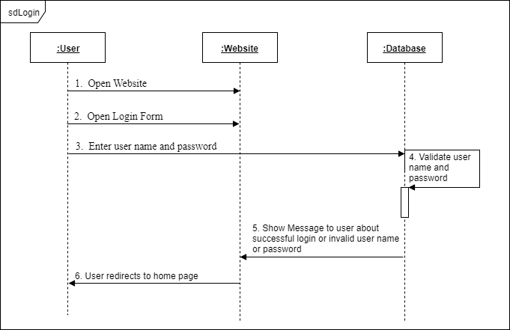

**4.2**.**2-Sequence Diagram for Case**

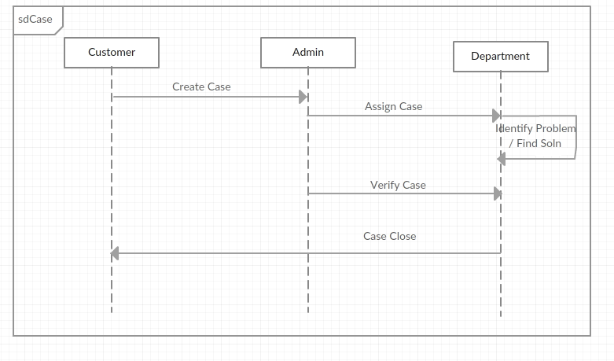

**4.2**.**3-Sequence Diagram Campaign**

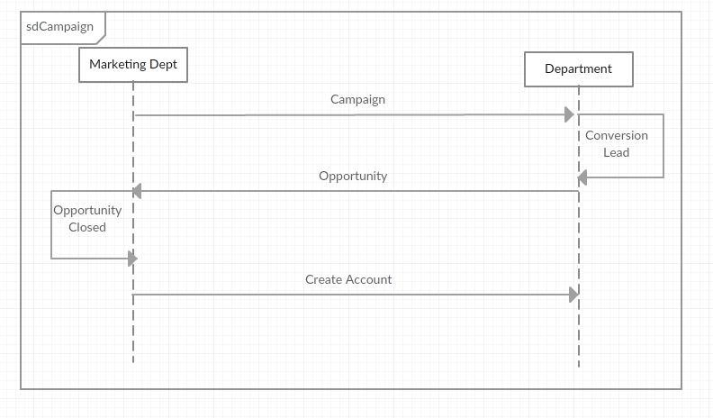

**4.3Activity Diagram**

**4.3**.**1. Activity Diagram for Login**

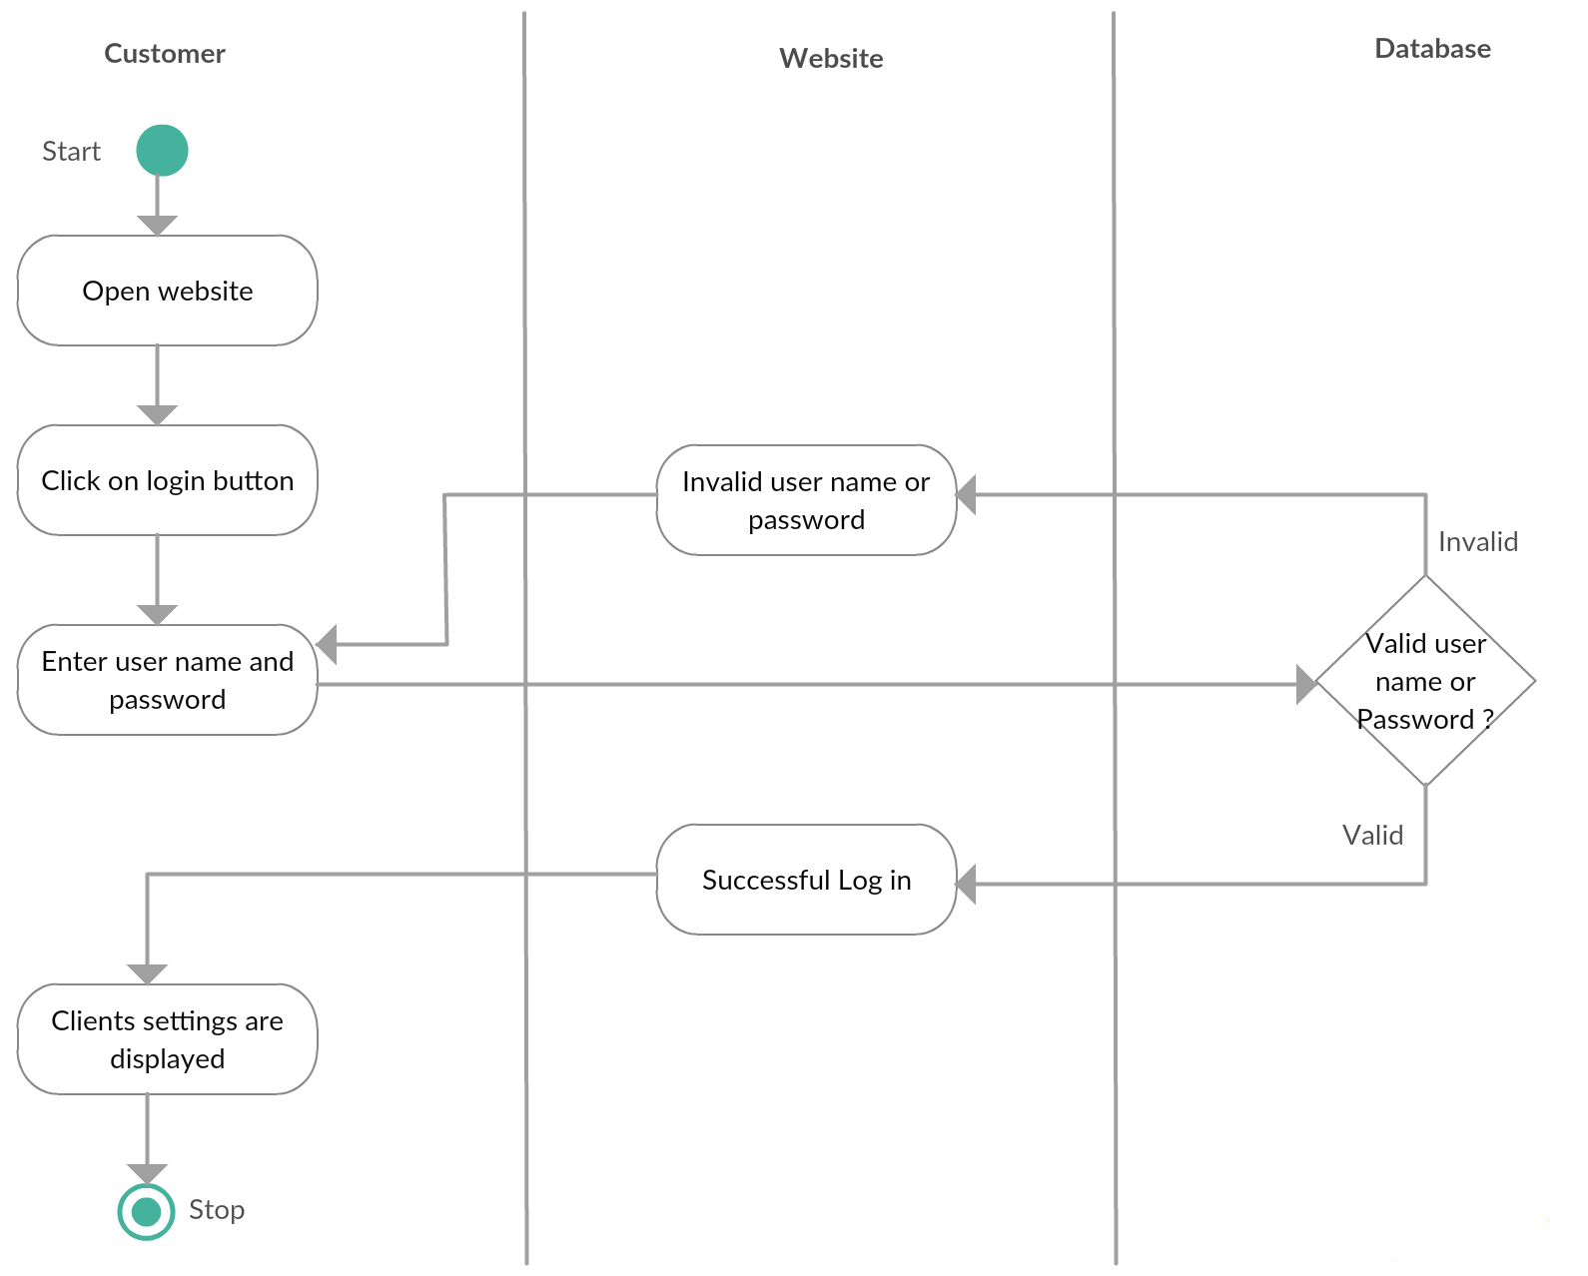

**4.3**.**2. Activity Diagram for Campaign**

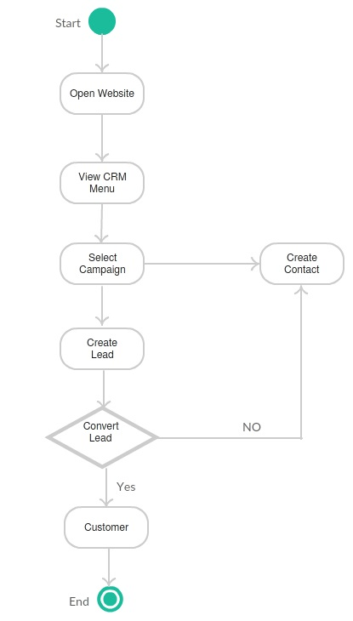

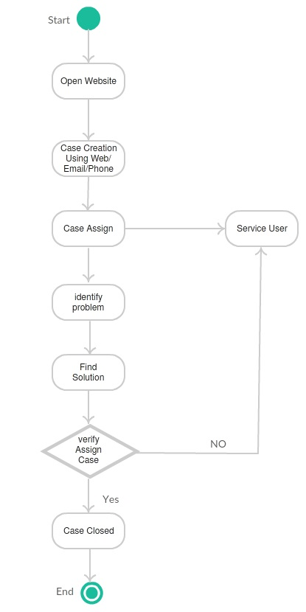**4.3**.**3. Activity Diagram for Case**

**4.4 Class Diagram**

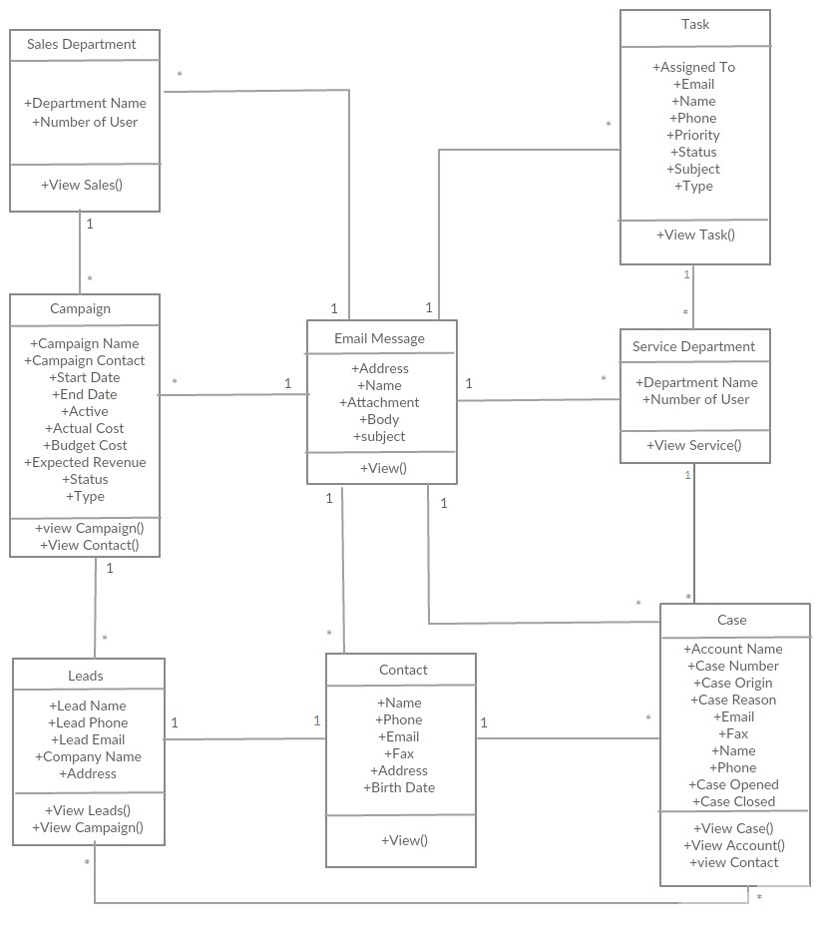

**4.5 Object Diagram**

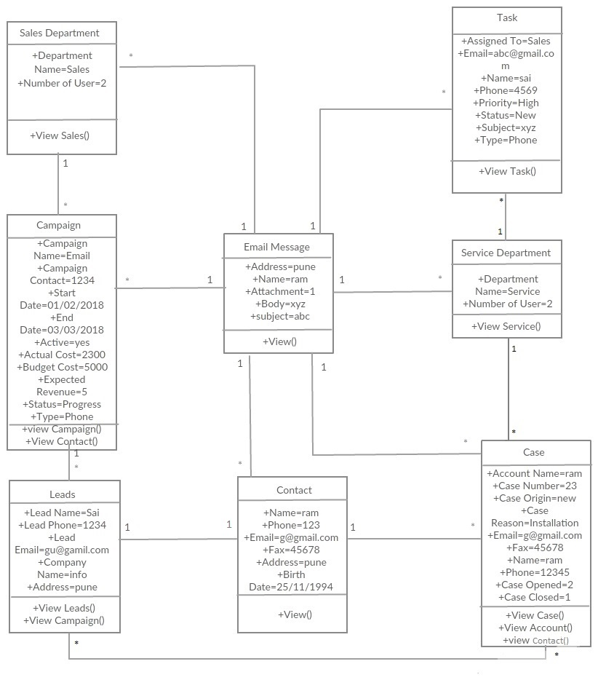

**4.6 Module Hierarchy Diagram**

